# **CTF Topic: PhishTank**



# **1. Introduction**



PhishTank is a collaborative clearinghouse for data and information about phishing on the internet. Users submit phishing URLs and verify the status of these URLs as either legitimate or phishing. This CTF challenge will guide you through using PhishTank to identify and analyze phishing URLs.

# **2. Tools and requirements**

PhishTank Account: Register for a free account on the PhishTank website.

Web Browser: For accessing the PhishTank interface.

# **3. Scenario**

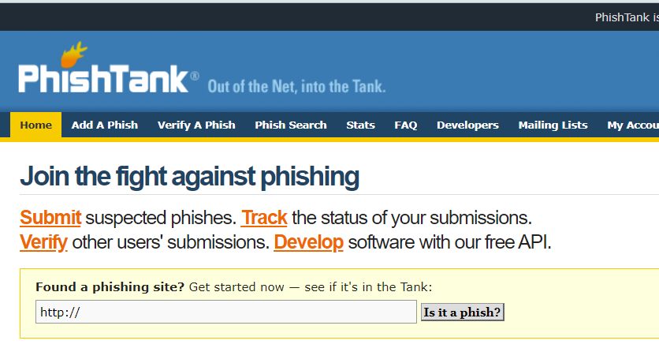

You are a cybersecurity analyst tasked with identifying and verifying phishing URLs. Your goal is to use PhishTank to find recent phishing URLs, verify their status, and analyse their characteristics.

# **4. Process to Follow while Performing CTF**

**Step 1: Register and Login:** Sign up for a free account on PhishTank and log in: <https://phishtank.org/>

**Step 2: Search for Phishing URLs:** Copy and Paste the URL: [www.google.com](http://www.google.com) **Step 3: Verify Phishing Status:** Check the status of the URLs to determine if they are verified as phishing.

# 

# **Let's Begin The Challenge**

# **Question**

**Flag 1:** What is the reference number of the given url?

**Answer: #11807**

**Flag 2:** What is the submitted date of the given url?

**Answer: Oct 2nd 2006**

# **Hint**

